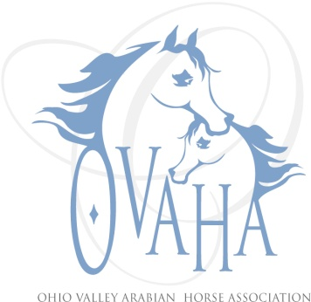

2014 Meeting Attendance/Minutes

Date of Meeting: ____________

P Officers P Board Members P Committee Chairs
P | Sherri Lewis - President | P | LaDon Donohoe ('15) |  | Becky Pitcock (Mbr)
P | Tammy Hawkey - Vice President | P | Caity Heigel (‘14) |  | Laraine Hune (TAIL)
 | Sharon Hanks - Secretary |  | Kristin Herder (’15) |  | Denise Mealy (Web)
P | Claire Williams - Treasurer |  | Larry Kinneer(’14) | P | Joe Subler (Hospitality)
 | Marcia Doncaster Past President (resigned) | P | Linda Laufer (’14) |  | Sharon Hanks (SS)
 |  |  | Trv-lyn Matta ('15) | P | Claire Williams (Youth)
 | Quorum
Meeting: Board Meeting with Long Lining Clinic
Notice given: Via e-mail, web page and Facebook page
Also present:
Location and Time: October, 2014

A very brief board meeting was held in order that all present could participate in and welcome guests for the long lining clinic.

Motion made and passed to:

- Assist in the expenses of the delegates to convention in the amount of $750 each.
- $40 for tack sale booth rental
- Reissue of $300 to Horseman’s Distress Fund from 2013 check that was never cashed

